
SMAD4 (R361S)
Catalog Number: CR-M26423
Gene Symbol: SMAD4, DPC4, JIP, MADH4, MYHRS
Description: Anti-SMAD4 (R361S) Mouse Monoclonal Antibody

Background: SMAD4 family member 4, also
known as SMAD4, is a protein that in human is
encoded by the SMAD4 gene. It is often found
mutated in many cancers. It acts as a tumor
suppressor that functions in the regulation of the TGF-β signal transduction pathway, which
negatively regulates growth of epithelial cells and the extracellular matrix (ECM). SMAD4
alterations have been found in
multiploid colorectal cancer and pancreatic
carcinoma . It is found inactivated in at least 50% of pancreatic cancers. It is also found mutated in the autosomal dominantdiseasejuvenile
polyposis syndrome (JPS).
Immunogen: A synthetic peptide from the
internal region of SMAD4 which includes the mutation of R361S, human origin.
Tested applications: ELISA, WB, IHC Recommended dilutions:
ELISA: 1:1000-1:2000
WB: 1:500-1:1000
IHC: 1:50-1:100
Concentration: 1 mg/ml
Host: Mouse
Clonality: Monoclonal
Purity: Purified from ascites
Format: Liquid Storage buffer:
Preservative: no
Constituents: PBS (without Mg2+ and Ca2+), pH
7.4, 150 mM NaCl, 50% glycerol

Species Reactivity: Recognizes R361S mutant, but not wild-type SMAD4 of vertebrates.
Storage Conditions: Store at -20°C. Avoid freeze / thaw cycles.
Western blot:
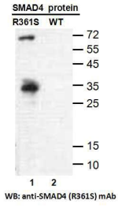
Western blot analysis of recombinant SMAD4 (R361S) and wildtype proteins. Purified
His-tagged SMAD4 (R361S) protein (lane1) and corresponding wild-type protein (lane2) were
blotted with anti-SMAD4 (R361S) monoclonal antibody (Cat. #26423).

For research use only. Not for diagnostic or therapeutic applications.

Immunofluorescence:
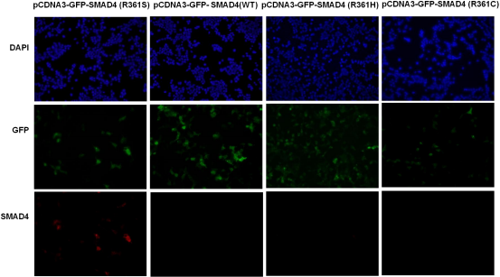

Immunofluorescence of cells expressing SMAD4 proteins with anti-SMAD4 (R361S) antibody. HEK293T cells were transfected with pCDNA3-GFP-SMAD4 (R361S) plasmid
pCDNA3-GFP-SMAD4 (WT) plasmid, pCDNA3-GFP-SMAD4 (R361H) plasmid or
pCDNA3-GFP-SMAD4 (R361C) plasmid, then fixed and stained with anti-SMAD4 (R361S) monoclonal antibody (Cat. #26423).

科博瑞（武汉）生物科技有限公司
TEL：027-87615885 15972062685
- mail：3636901710@qq.com
Web:www.coburybio.com

